Prefilled Cache Performance Tests

Stock Location Filter
The central, and most time-consuming routines, proved to be Replace_Inter and LLinkMLoc_Stock, so these routines were concentrated on.

No prefill cache – First Run.
This was run after a fresh install of Exchequer with Demo data.
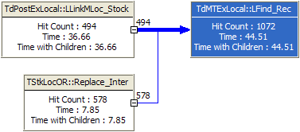

No prefill cache – Second Run
This was run after closing and re-opening Exchequer.
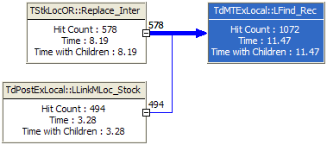

No prefill cache – Third Run
This was run after closing and re-opening Exchequer.
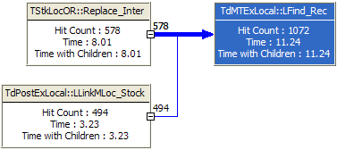

Prefill cache with Where clause – First Run
This was run after a fresh install of Exchequer with Demo data.

